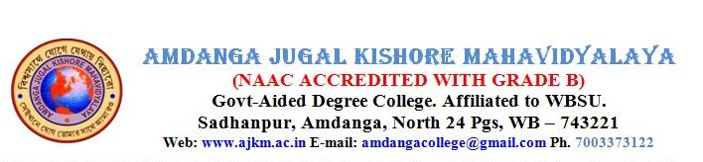



Ref. No

Date**15.07.2024**

**Admission Notice**

It is hereby notified to all those students who are seeking admission to UG 1st semester in 2024 that after the 1st phase of admission ends on 18.07.2024, some vacancies will automatically be generated as some reserved students' names appear in Unreserved category because of their eligibility as per merit index on the Allocation List, and hence repetitions duly occurred. Students should wait for upgradation to start when those newly generated vacant seats would be filled as per merit and preference of the applicants. Later on, college would take initiatives to de- reserve vacant reserved seats if these reserved seats repeatedly lie vacant due to dearth of adequate reserved students. In that case more vacancies are expected to be generated where applicants would get opportunities to take admission as per merit and preference and availability of vacant seats.

